https://arxiv.org/html/2407.20892v1#S4
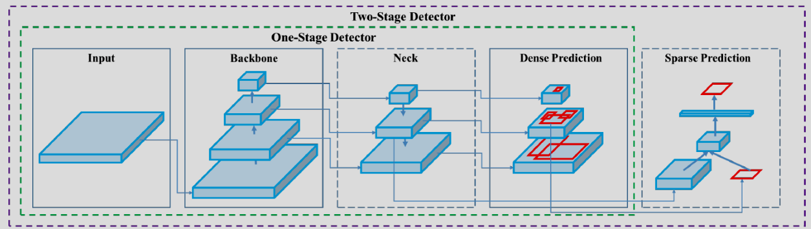
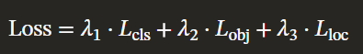
L_{cls}, L_{obj}, and L_{loc} represent the BCE loss for class prediction, BCE loss for objectness, and CIoU loss for localization, respectively.

DenseNet has gradient duplication problem. Since an input or output of a layer goes as input to all deeper layers, the gradient coming from all these paths would be similar. So, there is redundancy. CSPNet fixes this.
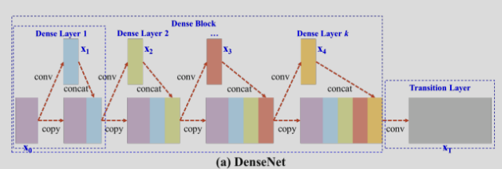
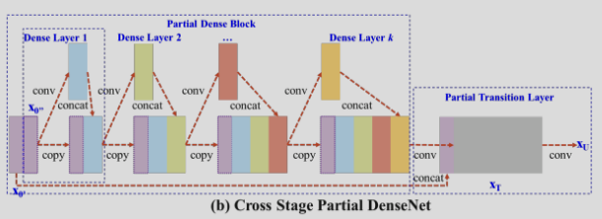
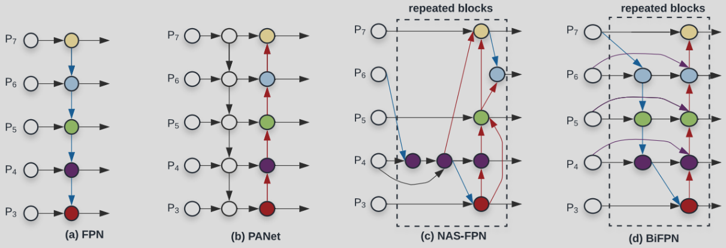

https://chatgpt.com/c/690ecd35-bf78-8320-a880-44a94121e91b
ChatGTPT:
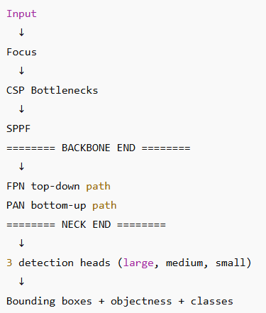
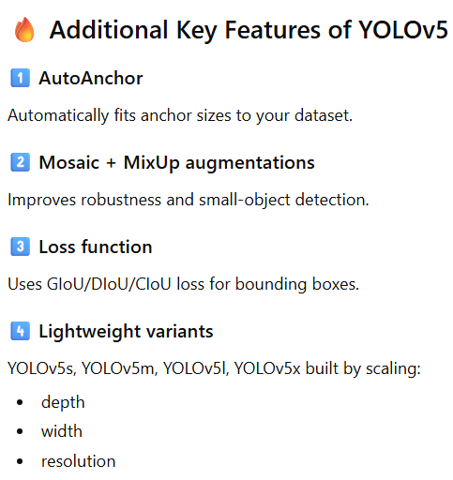

https://blog.roboflow.com/yolov5-improvements-and-evaluation/
- YOLOv5 created from YOLOv3 by translating Darknet to PyTorch
- 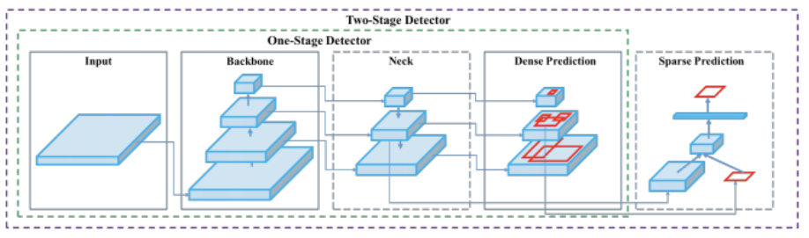

- Anchors are learnt automatically using K-means algorithm

- DenseNet was created to achieve below
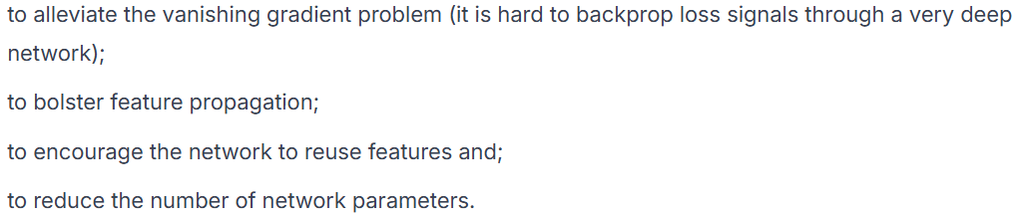
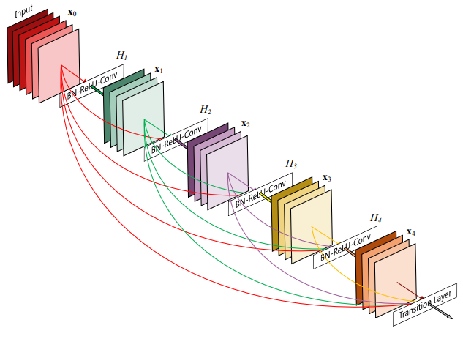
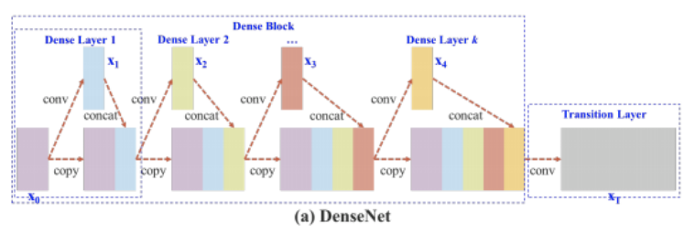
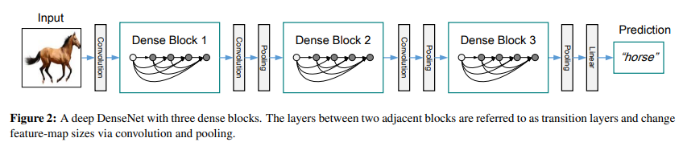

- 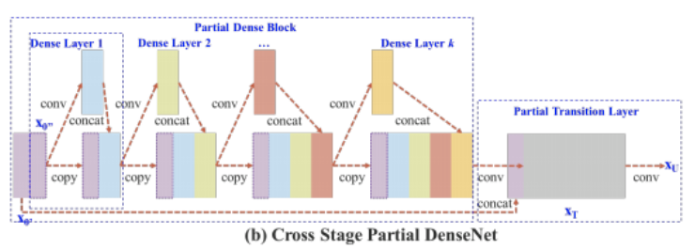

- YOLOv5 uses CSPDarknet as backbone.

- YOLOv5 uses PANet as neck for feature aggregation.
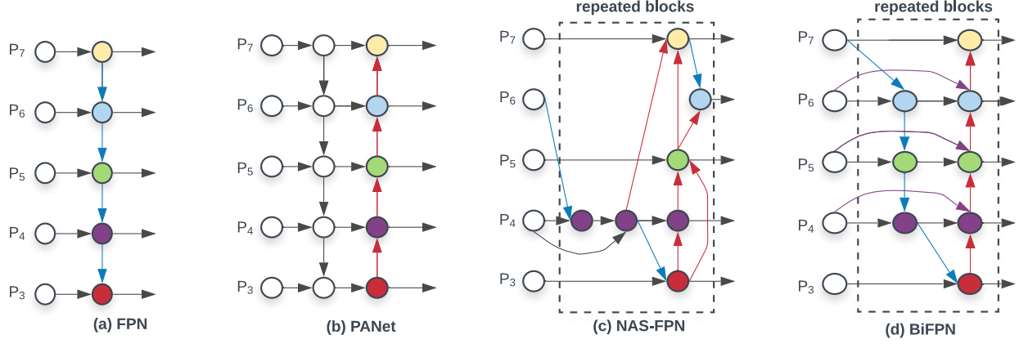

- https://chatgpt.com/s/t_691aae4c00f88191a47f620ae907e189
Backbone includes Focus layer, CSP bottleneck, Spatial Pyramid Pooling Fast (SPPF).
Neck outputs features at three scales: 80*80, 40*40, 20*20
Each feature scale has a separate head.

- Focus layer (ChatGPT)
Divide the input image in 4 parts: top left, top right, bottom left, bottom right
Concatenate them along channels and then feed to the network as input
e.g. if input image is of shape 3*640*640, the input to the network will be of shape 12*320*320

- Mosaic Augmentation:
Shrink and then combine 4 input images into a single image to be input to the model
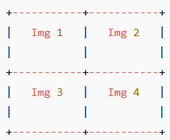
Introduces variation in background, object densities, lighting conditions, positions
To learn to detect smaller objects
Somewhat allows smaller batch size because of the diversity introduced in a single image
Because of the diversity, reduces overfitting

- MixUp augmentation
Given two images, create a new image to be input to the model
$$α*img1+\left(1-α\right)*img2$$

Do the same calculations for bounding boxes and class predictions.

Architecture: https://docs.ultralytics.com/yolov5/tutorials/architecture_description/#1-model-structure

